**CDA3315C Appendix Lab**

Table of Contents

**APPENDIX A** 2

**SETUP AND INSTALL APP SERVICE W/MYSQL** 2

**APPENDIX B** 3

**CREATE A NEW MYSQL DATBASE TABLE** 3

**APPENDIX C** 3

**BUILD NEW REPORTING TABLE AND LOAD DATA** 3

**APPENDIX D** 4

**CREATE A NEW PHP WEB PAGE FILE** 4

**APPENDIX E** 5

**CREATE A PHP CONNECTION STRING** 6

**APPENDIX F** 6

**WRITE PHP AND PROCESS DATABASE ACTIVITY** 6

**APPENDIX G** 7

**WRITE CSS3 SYNTAX TO FORMAT WEB PAGE** 7

**APPENDIX H** 9

**PUBLISH PHP FILE TO CLOUD WEB APP SERVICE** 9

**APPENDIX I** 10

**PREVIEW PHP WEBSITE IN CHROME DEVELOPER MODE** 10

**APPENDIX A**

**SETUP AND INSTALL APP SERVICE W/MYSQL**

1. Login to open.azure.com
2. Search for new service “Web App + MySQL”
   1. Select Create
   2. Give the service a unique Web App Name
   3. Change the Resource Group
   4. Change the Database Provider to “MySQL in App”
   5. Pin to Dashboard
   6. Select Create
3. Search for new service “MySQL” database
   1. Select Create
   2. Give the service a unique Database name
   3. Select Database Type to Shared
   4. Change Resource Group
   5. Click on View All > Change Pricing Tier to the cheapest possible
   6. Select Legal Terms > Select Create
   7. Pin to Dashboard
   8. Select Create
4. Go to the MySQL Database service
   1. Select Properties
   2. Get a COPY of the Connection String

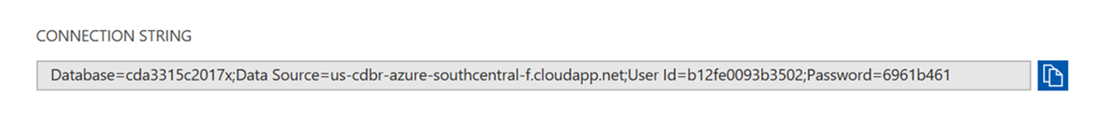

1. Go to the new Web App Service
2. Select Application Settings
   1. Scroll down to connection strings and select Add (+)
   2. Change the Database Type to MySQL
   3. Give the Connection String a Name (e.g. mySQLconn)
   4. PASTE the MySQL database connection string value from the MySQL database into the value field
   5. Click Save

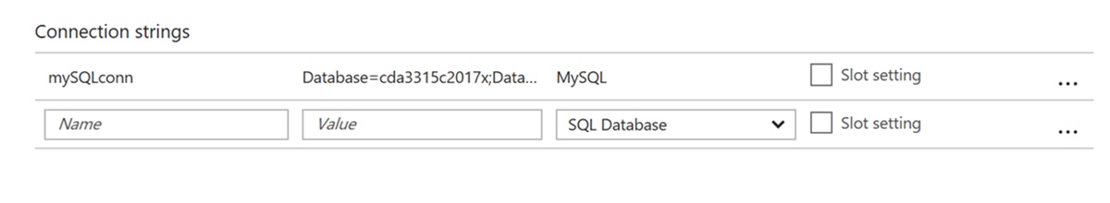

1. Select Extensions
   1. Search for phpMyAdmin > Click Ok > Click Ok
   2. Wait 1 or 2 minutes

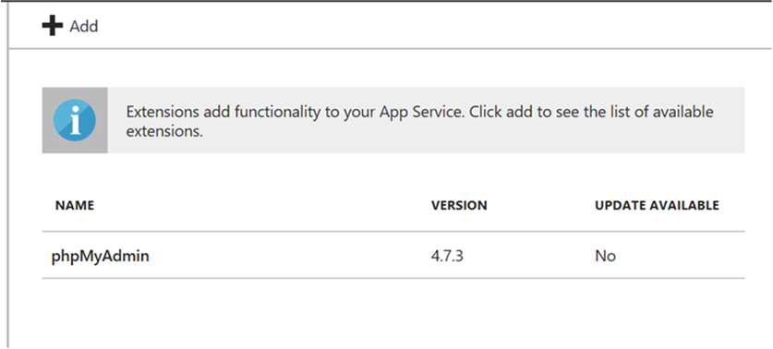

1. Connect to phpMyAdmin
   1. Click on the new phpMyAdmin extension
   2. Click on browse
   3. Login to server with Azure Student Account (e.g. Supersites user account)
   4. You should see your MySQL database
2. Done

**APPENDIX B**

**CREATE A NEW MYSQL DATBASE TABLE**

1. Login to portal.azure.com
2. Select Extensions > phpMyAdmin extension > Select Browse
3. Login to phpMySQL web server
   1. Select your database
   2. Click on SQL in the top menu
4. Run SQL and create a new database table called “tblCDA3315C”
   1. Copy/Paste SQL below into Query box

CREATE TABLE tblCDA3315C

(ID INT NOT NULL AUTO_INCREMENT,

PRIMARY KEY(ID),

FIRST_NAME VARCHAR(30),

LAST_NAME VARCHAR(30),

TELEPHONE VARCHAR(30))

1. Click on the GO button
2. Refresh the database
3. You should see the “tblCDA3315C” table in the database folder
4. Done

**APPENDIX C**

**BUILD NEW REPORTING TABLE AND LOAD DATA**

1. Create a new table called “tblUSERS”

CREATE TABLE tblUSERS (USERS_ID INT NOT NULL AUTO_INCREMENT, PRIMARY KEY(USERS_ID), FIRST_NAME VARCHAR(30), LAST_NAME VARCHAR(30), MIDDLE_NAME VARCHAR(30), TELEPHONE VARCHAR(30), FAX_NUMBER VARCHAR(30), STATUS VARCHAR(1), CREATED_BY VARCHAR(30), CREATED_DATE DATE, MODIFIED_BY VARCHAR(30),

MODIFIED_DATE DATE)

1. Create a new table called “tblADDRESSES”

CREATE TABLE tblADDRESSES (ADDR_ID INT NOT NULL AUTO_INCREMENT, PRIMARY KEY(ADDR_ID),

USERS_ID INT, ADDRESS1 VARCHAR(30), ADDRESS2 VARCHAR(30), CITY VARCHAR(30), STATE VARCHAR(30),

ZIPCODE INT, STATUS VARCHAR(1), CREATED_BY VARCHAR(30), CREATED_DATE DATE, MODIFIED_BY VARCHAR(30),

MODIFIED_DATE DATE)

1. Insert a new record into the tblUSERS table

[INSERT](https://webappmysqlras.scm.azurewebsites.net/phpmyadmin/url.php?url=https://dev.mysql.com/doc/refman/5.5/en/insert.html) INTO tblusers (USERS_ID, FIRST_NAME, LAST_NAME, MIDDLE_NAME, TELEPHONE, STATUS, CREATED_BY, CREATED_DATE, MODIFIED_BY, MODIFIED_DATE) [VALUES](https://webappmysqlras.scm.azurewebsites.net/phpmyadmin/url.php?url=https://dev.mysql.com/doc/refman/5.5/en/miscellaneous-functions.html#function_values) (1, 'JOHN', 'DOE', 'LITE', '123-456-7890', 'A', 'STUDENT', CURDATE(), 'STUDENT', CURDATE())

1. Insert a new record into the tblADDRESSES table

INSERT INTO `tbladdresses`(`ADDR_ID`, `USERS_ID`, `ADDRESS1`, `ADDRESS2`, `CITY`, `STATE`, `ZIPCODE`, `STATUS`, `CREATED_BY`, `CREATED_DATE`, `MODIFIED_BY`, `MODIFIED_DATE`) VALUES (1, 1, '1700 Clean Ave.', 'n/a' , 'TOPEKA', 'FL.', '10011', 'A', 'DEAN',CURDATE(), 'DEAN',CURDATE() )

1. Verify that the tables can talk to each other

SELECT tblB.FIRST_NAME, tblB.LAST_NAME, tblB.TELEPHONE, tblA.ADDRESS1, tblA.CITY, tblA.STATE, tblA.ZIPCODE

FROM tbladdresses tblA JOIN tblusers tblB ON tblB.users_id = tblA.users_id

WHERE tblB.USERS_ID = 1 AND tblA.STATUS = 'A' AND tblB.STATUS = 'A'

1. Results from the query

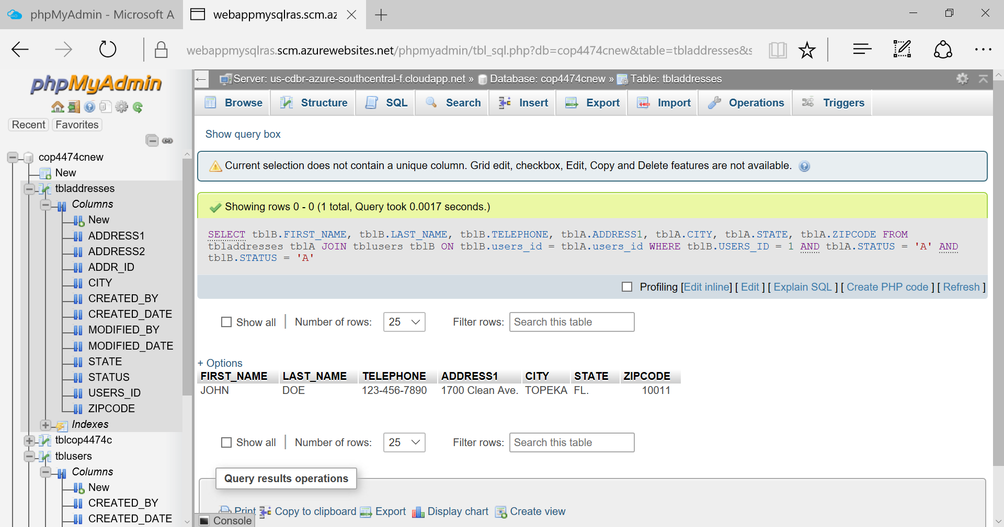

1. Done

**APPENDIX D**

**CREATE A NEW PHP WEB PAGE FILE**

1. Right click on the Desktop > Select New > Select Text Document
2. Change the file name to “index.php” > Press Enter
   1. Make sure the file type is “php” and not “txt”
3. Open the file index.php in Notepad.exe
4. Create an HTML5 web page template using this sample code:

<!DOCTYPE html>  
<html>

<head>

<title>Registration Form</title>

<!-- Bootstrap Reference Links -->

<link rel="stylesheet" href="https://maxcdn.bootstrapcdn.com/bootstrap/3.3.7/css/bootstrap.min.css">

<script src="https://ajax.googleapis.com/ajax/libs/jquery/3.2.1/jquery.min.js"></script>

<script src="https://maxcdn.bootstrapcdn.com/bootstrap/3.3.7/js/bootstrap.min.js"></script>

<!-- End of Bootstrap References -->

</head>  
<body>  
<div id="Div1" class="col-sm-4">  
<h1>Rasmussen Registration Form</h1>  
<p>Fill in your name and telephone, then click <strong>Submit</strong> to register.</p>

<form method="post" action="index.php" enctype="multipart/form-data" >

FIRST_NAME <input type="text" name="first_name" id="first_name"/></br>

LAST_NAME <input type="text" name="last_name" id="last_name"/></br>

TELEPHONE <input type="text" name="telephone" id="telephone"/></br>

<input type="submit" id="submit1" value="Submit" />

</form>

<?php

?>

<div id="Div2">

<p>This is a block paragraph #2</p>

</div> </div><div>

<div id="Div3">

<p>This is a block paragraph #3</p>

</div>

</body>  
</html>

1. Copy and Paste the HTML sample into the index.php file > Save the file
2. Preview the sample code in the Google Chrome browser
   1. It should look similar to this:

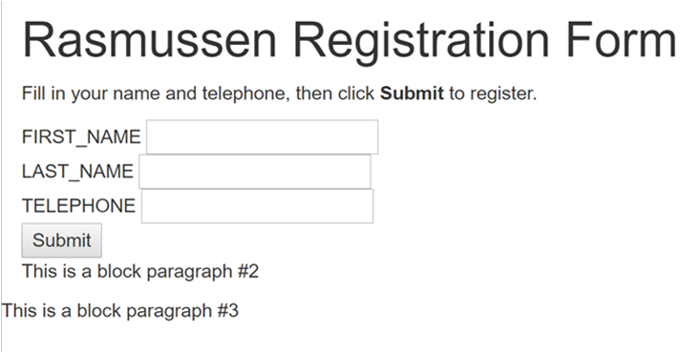

1. Done

**APPENDIX E**

**CREATE A PHP CONNECTION STRING**

1. Open the course index.php file in Notepad.exe
2. Copy and paste the PHP syntax connection string inside the php tags (e.g. <?php ?>)

// DB connection info

// Within the PHP tags, add PHP code for connecting to the database.

$host = "Put App Service URL Here ";

$user = "Put DB UserID Here";

$pwd = "Put DB Password Here";

$db = "Put Database Name Here";

1. Update the $host variable value with your MySQL database service URL
   1. Go to the student cloud portal and select the MySQL database service
   2. Select the Overview
   3. Get a copy of the MySQL database service “Hostname” URL
   4. Paste the URL value between the php “$host” double quotes
2. Update the connection string variable values with your MySQL database information
   1. Go to the student cloud portal and select the MySQL database service
   2. Select the Properties
   3. Get a copy of the UserID value from the MySQL database service
   4. Paste the UserID value between the php $user double quotes
   5. Get a copy of the Password value from the MySQL database service
   6. Paste the Password value between the php $pwd double quotes
   7. Get a copy of the database value from the MySQL database service
   8. Paste the Database value between the php $db double quotes
3. Preview the sample code in the Google Chrome browser
   1. Simply make sure you do not have any errors
   2. You will not be able to preview the PHP syntax with a browser
   3. The PHP will not work until the index.php file is published on a web hosting server that supports PHP
4. Done

**APPENDIX F**

**WRITE PHP AND PROCESS DATABASE ACTIVITY**

1. Open the course index.php file in Notepad.exe
2. Write PHP to connect to the MySQL database service
3. Copy and paste the PHP syntax to connect

// Connect to database.

try {

$conn = new PDO( "mysql:host=$host;dbname=$db", $user, $pwd);

//$conn->setAttribute( PDO::ATTR_ERRMODE, PDO::ERRMODE_EXCEPTION );

}

catch(Exception $e){

die(var_dump($e));

}

1. Copy and paste the PHP syntax to insert a new record

//Following the database connection code, add code for inserting registration information into the database.

if(!empty($_POST)) {

try {

$first_name = $_POST['first_name'];

$last_name = $_POST['last_name'];

$telephone = $_POST['telephone'];

// Insert data

$sql_insert = "INSERT INTO tblCDA3315C(FIRST_NAME, LAST_NAME, TELEPHONE)

VALUES (?,?,?)";

$stmt = $conn->prepare($sql_insert);

$stmt->bindValue(1, $first_name);

$stmt->bindValue(2, $last_name);

$stmt->bindValue(3, $telephone);

$stmt->execute();

}

catch(Exception $e) {

die(var_dump($e));

}

echo "<h3>You're Registered!</h3>";

}

1. Copy and paste the PHP syntax to retrieve data from the database service

//Finally, following the code above, add code for retrieving data from the database.

$sql_select = "SELECT * FROM tblCDA3315C";

$stmt = $conn->query($sql_select);

$registrants = $stmt->fetchAll();

if(count($registrants) > 0) {

echo "<h2>People Who Are Registered:</h2>";

echo "<table boarder=2>";

echo "<tr><th>FIRST_NAME</th>";

echo "<th>LAST_NAME</th>";

echo "<th>TELEPHONE</th></tr>";

foreach($registrants as $registrant) {

echo "<tr><td>".$registrant['FIRST_NAME']."</td>";

echo "<td>".$registrant['LAST_NAME']."</td>";

echo "<td>".$registrant['TELEPHONE']."</td></tr>";

}

echo "</table>";

} else {

echo "<h3>No one is currently registered.</h3>";

}

1. Preview the sample code in the Google Chrome browser
   1. At this point, you should expect several errors since the browser is trying to connect to the database service
   2. This is normal and for now, try to ignore the errors
2. Done

**APPENDIX G**

**WRITE CSS3 SYNTAX TO FORMAT WEB PAGE**

1. Open the course index.php file in Notepad.exe
2. Write a new <Script> tag in the index.php file
   1. Inside the <head> tag create a new open/closing set of script tags (e.g. <style type="text/css"> </script>)
3. Expand the script tags so there are empty lines between them
4. Copy and paste the CSS wrapper class syntax between the script tags

.wrapper {

overflow: hidden;

}

1. Add a new wrapper <div> tag around the three main <div> tags in the body of the index.php file
   1. This tag will wrap around all of the other <div> tags

<div id="DivHeader" class="wrapper">

</div>

1. Copy and paste the CSS syntax to format support for different device screen sizes
   1. Make sure this CSS syntax is between the <script> tags

/*PHONE CSS */

@media screen and (min-width: 10px) and (max-width: 550px), (min-device-width: 10px) and (max-device-width: 550px) {

#Div1, #Div2, #Div3, #tblGrid {

border:2px solid black;

width:100%;

float:left;

font-size: 2em;

}

#first_name, #last_name, #telephone {

width: 100%;

border: 2px solid black;

}

#submit1 {

background-color: #ffff80;

}

}

/*TABLET CSS */

@media screen and (min-width: 551px) and (max-width: 900px), (min-device-width: 551px) and (max-device-width: 900px) {

#Div1, #Div2, #Div3 {

border:2px solid black;

width:100%;

float:left;

font-size: 4em;

}

#first_name, #last_name, #telephone {

width: 100%;

border: 2px solid black;

}

#submit1 {

background-color: #ccb3ff;

}

}

/*FULL SCREEN CSS */

@media screen and (min-width: 901px), (min-device-width: 901px){

body { background-color: #fff; border-top: solid 10px #000;

color: #333; font-size: .85em; margin: 20; padding: 20;

font-family: "Segoe UI", Verdana, Helvetica, Sans-Serif;

}

h1, h2, h3,{ color: #000; margin-bottom: 0; padding-bottom: 0; }

h1 { font-size: 2em; }

h2 { font-size: 1.75em; }

h3 { font-size: 1.2em; }

table { margin-top: 0.75em; boarder: 2px; }

th { font-size: 1.2em; text-align: left; border: none; padding-left: 0; }

td { padding: 0.25em 2em 0.25em 0em; border: 0 none; }

#Div2, #Div3 {

border:2px solid black;

float:left;

font-size: 4em;

}

#Div1 {

border:2px solid black;

float:left;

font-size: 4em;

width:100%;

}

}

1. Preview
2. Done

**APPENDIX H**

**PUBLISH PHP FILE TO CLOUD WEB APP SERVICE**

1. Go to student cloud portal account > Select Web App service w/MySQL
2. Select Deployment credentials option
3. Enter the FTP username and password > then save in the top menu
4. Go out of the Deployment > Select Overview option
5. Get a copy of the FTP hostname URL
6. Go to you Windows desktop and open a File Explorer window
7. Paste a copy of the FTP hostname URL into the address bar > press ENTER
8. You will then bet prompted for the FTP user and password credentials

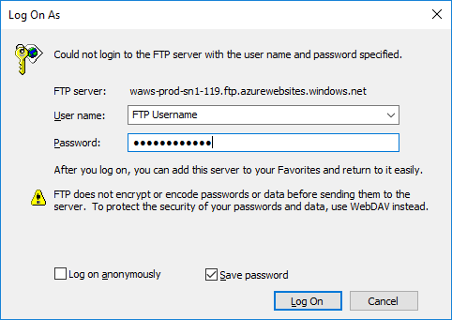

1. Get the FTP username from the Web App service Overview option
2. Get the FTP password from the Web App service Deployment credentials option
3. An FTP connection to the App Service will open and show three folders

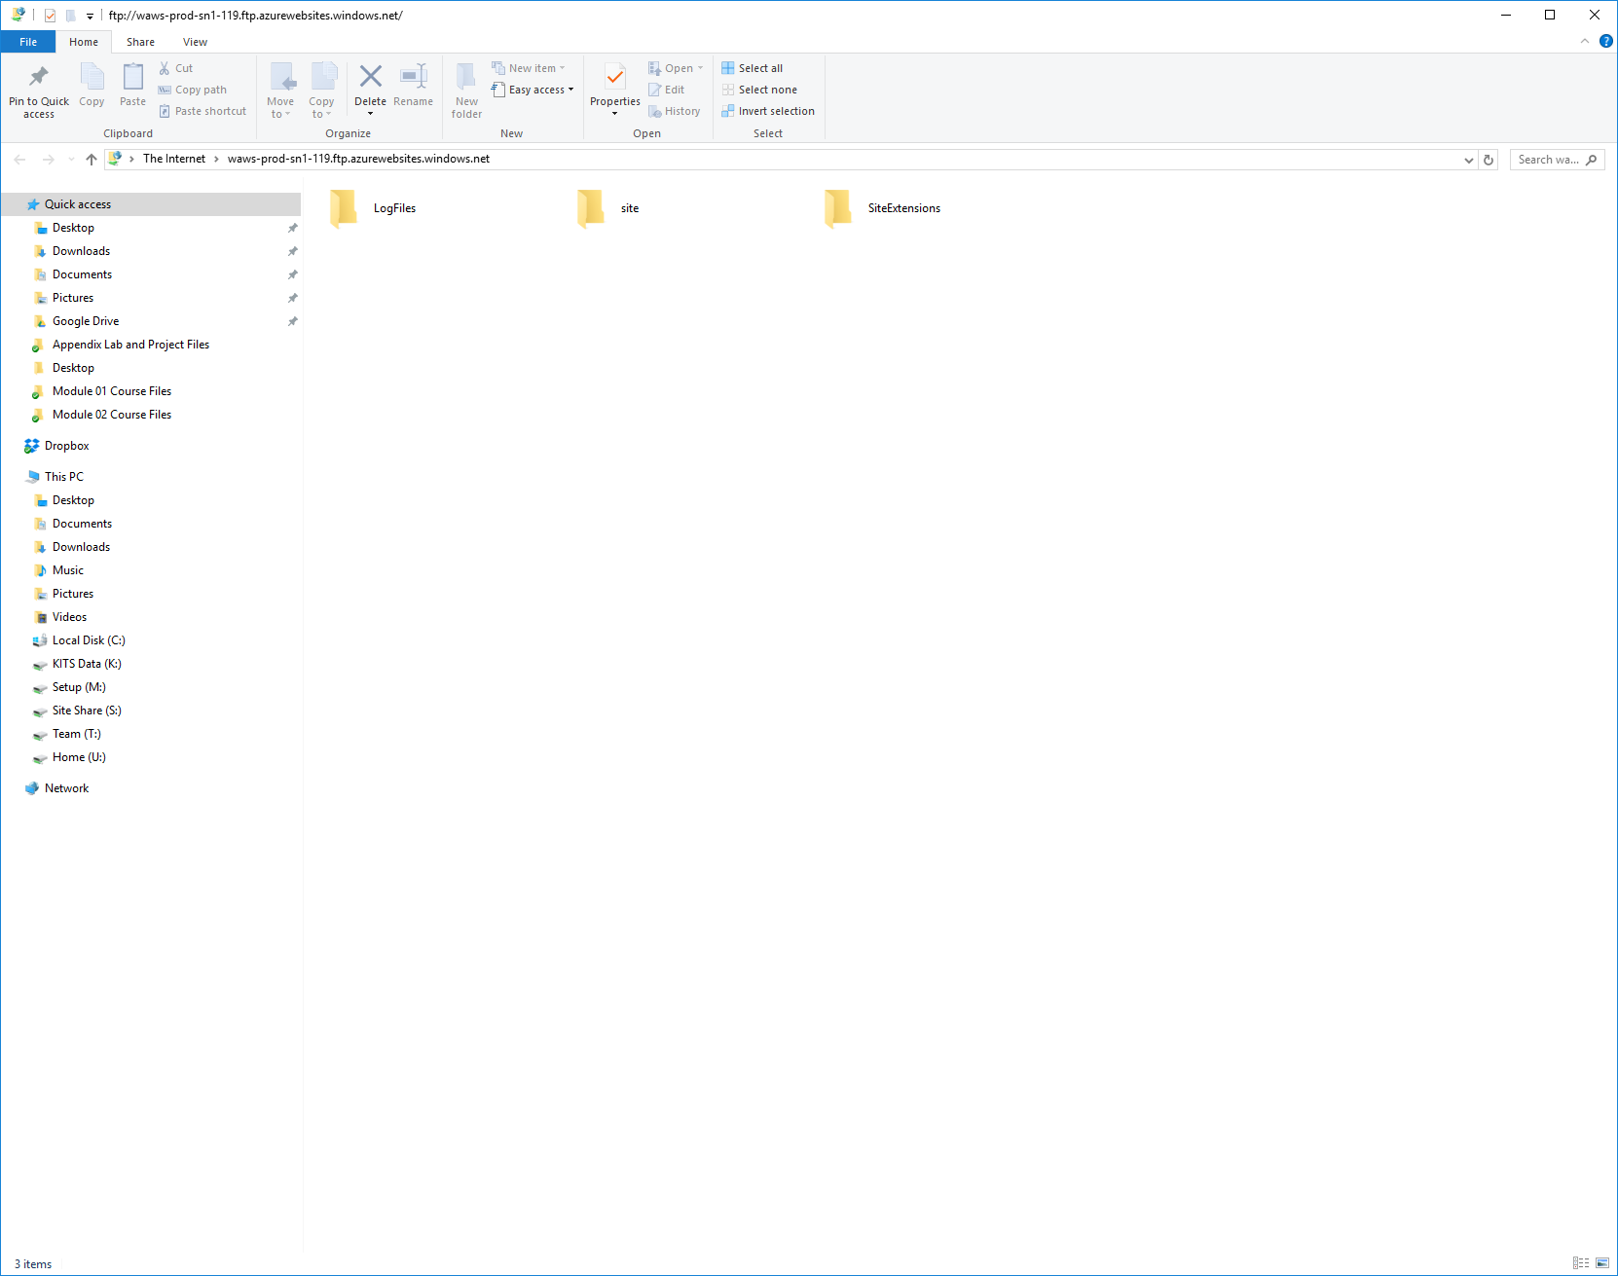

1. Select folder called “site” > Select folder called “wwwroot”
2. Copy and paste a copy of the index.php file into the “wwwroot” folder path

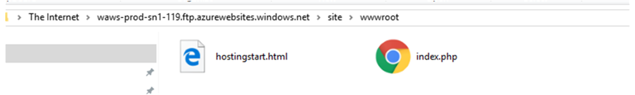

1. Go back to the Web App service > select Overview
2. Click on the Web App service URL
   1. It will open in a browser window
3. You might need to add /index.php at the end of the URL in the browser address bar
   1. http://app-service-url/index.php
4. Preview the sample code in the Google Chrome browser
   1. You should not have any errors
   2. The web app will connect to the database service once you press the submit button
   3. Test the app and complete the form > press the submit button
   4. You should get a “You’re Registered!” message
   5. The form information should populate below the form under “People Who Are Registered”
5. Done

**APPENDIX I**

**PREVIEW PHP WEBSITE IN CHROME DEVELOPER MODE**

1. Go to student cloud portal account > Select Web App service w/MySQL
2. Select Overview
3. Click on the Web App service URL
   1. It will open in a browser window
4. You might need to add /index.php at the end of the URL in the browser address bar
   1. http://app-service-url/index.php
5. Preview the web site page in a Google Chrome browser

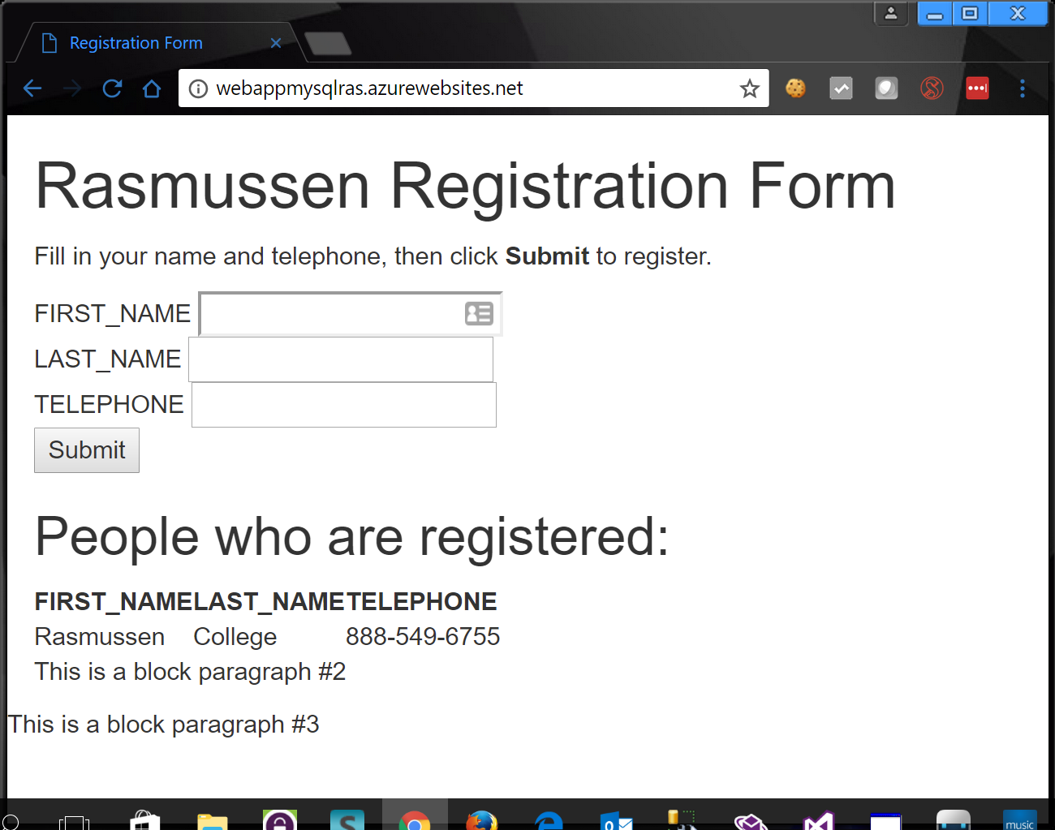

1. In the Google Chrome browser go to the top menu > select the button with three dots in the top right.
   1. This is the browser options dialog window.
2. Go to More Tools > Select Developer Tools

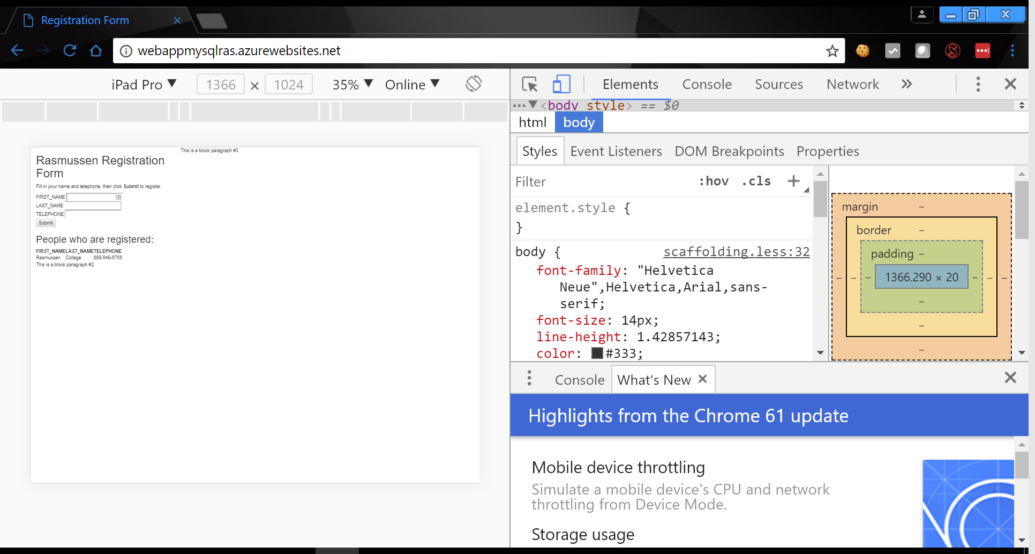

1. Change the menu device dropdown control to another device, like “Galaxy S5”
2. You will notice the left panel view changed to fit the size of device
3. This developer mode in Chrome let’s you see how your web site looks and feels to many different types of devices that are already configured within your Chrome browser
4. Done